**88WS14-EXAM INSPECTION**

**CODE**

1) running program /10 pts.

2) Printing books on screen /10 pts.

3) Total amount of money for the books /10 pts.

4) Code Quality /10 pts.

5) UML Class Diagram /10 pts

**DATE: 02th december 2021**

20 GUAMAN VEJARANO ANGEL DAVID

1) running program 10/10 pts.

2) Printing books on screen 5/10 pts.

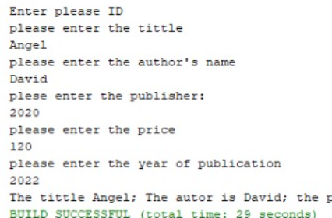

3) Total amount of money for the books 0/10 pts.

4) Code Quality 4/10 pts.

5) UML Class Diagram 7/10 pts

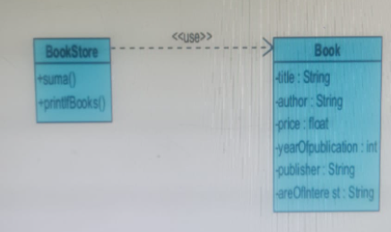

Total:26/50

inspector: Guitarra Jhon

21 GUITARRA SANCHEZ JHON ALEXANDER

Inspector: Jose Guzman

1) running program 0/10 pts.

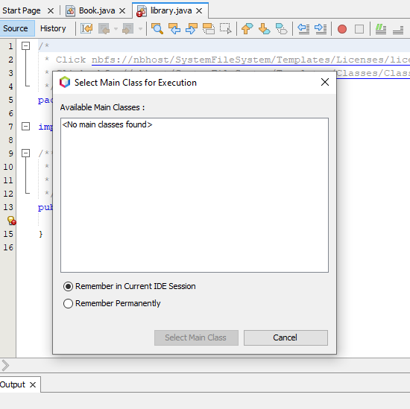

2) Printing books on screen 0/10 pts.

3) Total amount of money for the books 0/10 pts.

4) Code Quality 5/10 pts.

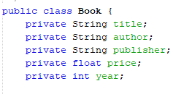

5) UML Class Diagram 10/10 pts

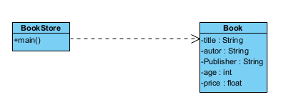

Total:15/50